**Supplementary Materials: Appendix 1**

**Alien characters used in training and test trials**

Each alien occurred with equal frequency in red or blue in the experiment.

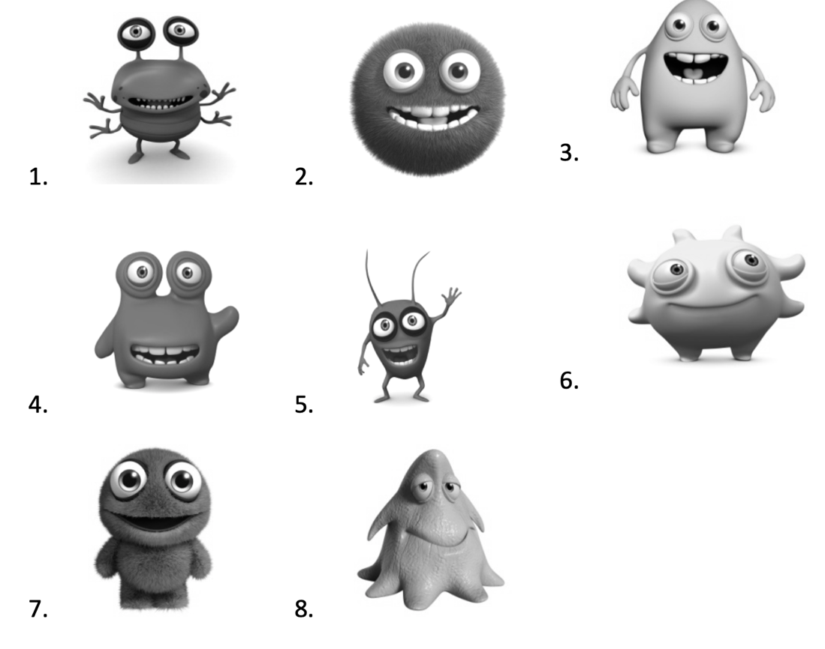

**Pseudoword lexicon used in the experiment**

The 14 bisyllabic words used as content words (nouns, verbs, and adjectives) were: *barget, bimdah, chelad, dingep, fisslin, goorshell, haagle, jeelow, limeber, makkot, nellby, pakrid, rakken, sumbark.* Two monosyllabic words were used as grammatical role markers (subject/object): *tha, noo*.